1. **What does ECMAScript stand for? \***

* European CPU Manufacturers Association Script
* Ecma International Scripting Language
* General Purpose Programming Language
* European Computer Manufacturers Association Script

1. **Is Java and JavaScript similar? \***

* Yes
* Almost similar
* No

1. **When JavaScript was invented? \***

* October 1999
* September 1998
* November 1995
* September 1993
* September 1995

1. **Who created JavaScript? \***

* Jordan Walke
* Dennis Ritchie
* Mark Zuckerberg
* James Gosling
* Brendan Eich

1. **What is the latest version of ECMAScript? \***

* ES2021
* ES21
* ES2020
* ES6
* ES2022

1. **If 'script.js' file is in the same folder index.html file is, what will be the correct src for <script> Tag? \***

The Questions can have more than one correct answer.

* .//script.js
* ../script.js
* .\script.js
* ./script.js
* script.js

1. **How to print the contents of the current window with JavaScript? \***

The Questions can have more than one correct answer.

* window.print()
* document.print()
* print()

1. **Why would you use console.log? \***

The Questions can have more than one correct answer.

* To access an HTML element
* JavaScript does not have any console.log function
* Print data to user
* To debug JavaScript Code
* For testing purpose

1. **What is the main purpose of innerHTML? \***

The Questions can have more than one correct answer.

* Print the content of the current window
* Testing the Code
* Used to write Dynamic Content on HTML
* To set or modify the Markup Content

1. **What is Chrome Dev Tool? \***

The Questions can have more than one correct answer.

* Shortcut tool for Developer
* Only tool to write JavaScript
* Latest Chrome Browser
* Developer tool to learn JavaScript
* Debugging tool for Developer

1. **If a JavaScript statement does not fit on one line what you should do? \***

The Questions can have more than one correct answer.

* Sue against JavaScript
* Stop Coding
* Zoom Out the Browser window
* Break the Computer
* Break the Line

1. **What is a white space? \***

The Questions can have more than one correct answer.

* Game Characters
* Nothing
* Any Visual Representation
* Empty Space

1. **Which statement is true for JavaScript Statement? \***

The Questions can have more than one correct answer.

* Statements are the commands that tell the browser to what action to perform.
* We can write multiple statements on one line
* JavaScript Statements are called JavaScript Code

1. **JavaScript block is delimited by \***

The Questions can have more than one correct answer.

* Second Brackets
* First Brackets
* []
* {}
* a pair of Curly Brackets

1. **What is the purpose of Code Blocks? \***

The Questions can have more than one correct answer.

* Programmers often like to use Code Blocks
* Because It helps programmers to learn programming in One day
* To define statements to be executed together.
* To group statements together

1. **JavaScript statements are composed of: \***

The Questions can have more than one correct answer.

* Values, Operators, Expressions, Keywords, and Comments

1. **Why do we use variables in programming? \***

The Questions can have more than one correct answer.

* To display Data
* To Log Data
* To separate JavaScript statements
* To label and store data in memory

1. **Types of JavaScript Values \***

The Questions can have more than one correct answer.

* Output Values
* Operator Values
* Print Values
* Literals
* Fixed Values
* Variable Values

1. **What is JavaScript Literals? \***

The Questions can have more than one correct answer.

* Operator Values
* Print Values
* Variable Values
* Fixed Values
* Number
* String

1. **Why equal sign (=) is used in programming? \***

The Questions can have more than one correct answer.

* To Check the equality
* To compare the equality
* To Set a value of a variable
* To Assign Values

1. **What is the correct syntax for adding comments in JavaScript? \***

The Questions can have more than one correct answer.

* !!
* <!-- this is Comment -->
* \\ this is Comment
* /* this is Comment */
* // this is Comment

1. **Why JavaScript uses Arithmetic Operators? \***

The Questions can have more than one correct answer.

* To identify actions to be performed
* To Assign Values
* Cause JavaScript Don't have Operation Theater
* To Compute Values
* To Perform Mathematical Calculations

1. **Which syntax is correct for camel case? \***

The Questions can have more than one correct answer.

* Learn with Sumit
* lEarnWithSumit
* Learn_with_sumit
* learnWithSumit

1. **What are expressions in JavaScript? \***

The Questions can have more than one correct answer.

* Set of rules that define a correctly structured JavaScript program
* Expressions are used to store data values
* Expressions are programming instructions
* Unit of code that can be evaluated to a value

1. **What are the JavaScript Variable Keywords? \***

The Questions can have more than one correct answer.

* var
* let
* const

1. **Which Statement is not Correct - \***

The Questions can have more than one correct answer.

* var lws = "30k";
* var ten = 5 + 5 + "Five";
* var 5 = five; var x - 50;
* var x+y = 10;
* var 0range = 20;
* var "x" = 100;

1. **How many ways to declare Variables in JavaScript? \***

* 5
* 1
* 3
* 4

1. **`var x = 100;` - What is going on here ? \***

The Questions can have more than one correct answer.

* We are declaring variable 5
* We are comparing 'x' and 100
* We are defining a variable called 'x' and assigning its value 100
* We are assigning value 100 to 'x'

1. **Which Statement is Correct? \***

The Questions can have more than one correct answer.

* Variable x and Variable X is similar
* Variable Name can start with letters or digit
* 'var' can be variable name
* Variables are Case Sensitive
* Variables names can start with $ or _
* Variable Name can start with letters

1. **The purpose of Variable is to \***

The Questions can have more than one correct answer.

* Remove Data
* Declare Value
* Assign Value
* Store Value

1. **When did ECMAScript 6 come out? \***

The Questions can have more than one correct answer.

* 2026
* 2006
* 2016
* 2015

1. **What is the output of the following code? \***

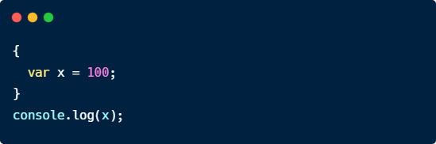

* x CAN be used here
* x = 100
* ReferenceError: x is not defined
* 100

1. **What is the output of the following code? \***

The Questions can have more than one correct answer.

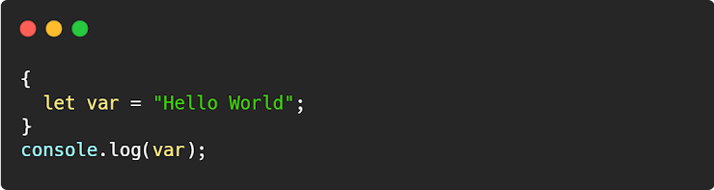

* SyntaxError: 'var' has already been declared
* Hello World
* ReferenceError: var is not defined
* Uncaught SyntaxError: Unexpected token 'var'

1. **What happens when we declare a let variable twice? \***

The Questions can have more than one correct answer.

* Nothing Happens
* I will work perfectly
* It is fine to declare let variable twice
* It will show Error
* It will show 'SyntaxError'

1. **What is the output of the following code? \***

The Questions can have more than one correct answer.

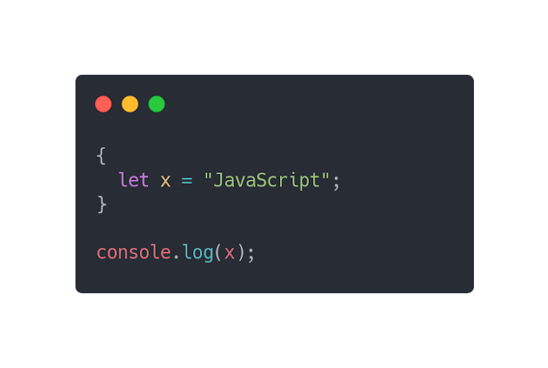

* "JavaScript"
* JavaScript
* SyntaxError: 'name' has already been declared
* ReferenceError: x is not defined

1. **How do we put JavaScript code inside HTML file? \***

The Questions can have more than one correct answer.

* <link type='javascript'>
* inside opening and closing </script> tag
* inside <javascript> tag
* inside opening and closing <script> tag

1. **Which one is correct? \***

The Questions can have more than one correct answer.

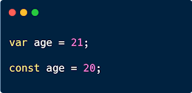

* Option 1

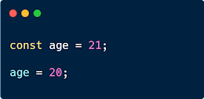

* Option 2

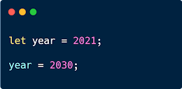

* Option 3

1. **What is the difference between const and let? \***

The Questions can have more than one correct answer.

* variables declared with const can be reassigned but can't be reassigned in case of let
* const allows to reassign after it has been assigned
* const is almost exactly the same as let
* variables declared with const can't be reassigned but can be reassigned in case of let

1. **Which operators are used for mathematical calculations? \***

The Questions can have more than one correct answer.

* Comparison Operators
* String Operators
* Logical Operators
* Assignment Operators
* Arithmetic Operators

1. **Which operators are used to perform comparison? \***

The Questions can have more than one correct answer.

* Logical Operators
* String Operators
* Arithmetic Operators
* Assignment Operators
* Comparison Operators

1. **What is the JavaScript operator for multiplication? \***

* x
* %
* **
* Exponentiation
* *

1. **What is the correct example of JavaScript String Operators? \***

The Questions can have more than one correct answer.

* let age = 30 + 40;
* const value = "Hello" && "World"
* const text = "I Love" + " Bangladesh";
* let age = 25 + " years old";

1. **What is modulus (%) operator used for? \***

The Questions can have more than one correct answer.

* To find the Percentage Value
* It helps to create new JavaScript module
* Returns the remainder after dividing one number by another
* It returns the remainder of left dividing the hand operand by right hand operand

1. **What is the output of code below? \***

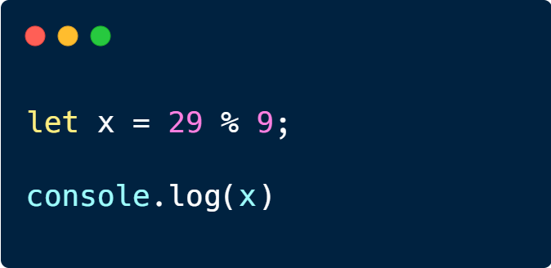

* 0.09
* .9
* .02
* 2

1. **Inside 'information' object, we call 'name' and 'tutorials' as - \***

The Questions can have more than one correct answer.

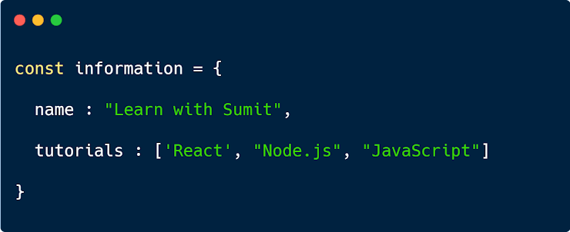

* Function
* Array
* Value
* Object Method
* String
* Object Property

1. **Which one will throw an error? \***

The Questions can have more than one correct answer.

* let str = "He called is called Johnny";
* let str = "He called is called " + "Johnny";
* let str = "He called is called 'Johnny'";
* let str = 'He called is called Johnny '';

1. **What data type is True False? \***

The Questions can have more than one correct answer.

* Array
* null
* String
* undefined
* Number
* Boolean

1. **What are textual data types in JavaScript? \***

The Questions can have more than one correct answer.

* Array
* Text
* null
* undefined
* Number
* String

1. **What is the use of 'typeof' operator in JavaScript? \***

The Questions can have more than one correct answer.

* Declare the type of a JavaScript variable
* Assign the type of a JavaScript variable
* Remove the type of a JavaScript variable
* Find the type of a JavaScript variable

1. **Which one is not a JavaScript data type? \***

The Questions can have more than one correct answer.

* number
* string
* array
* undefined
* typeof

1. **What are the data type of JavaScript? \***

The Questions can have more than one correct answer.

* String
* Number
* Boolean
* Function
* Object
* Symbol
* BigInt
* Null
* Undefined

1. **What is the output of code below? \***

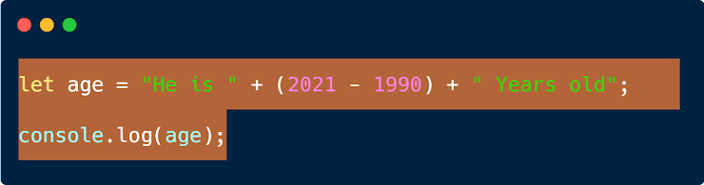

* He is(2021 - 1990)Years old
* He is (2021 - 1990) Years old
* He is (31) Years old
* He is 31 Years old

1. **Which keyword is used to define a function? \***

The Questions can have more than one correct answer.

* public static void main
* object
* call
* fun
* invoke
* function

1. **What is argument? \***

The Questions can have more than one correct answer.

* Return Value of a function
* Information that is passed into a function definition
* The values received by the function when it is invoked
* The Value we pass while invoking a function

1. **What is the purpose of return statement in a Function? \***

The Questions can have more than one correct answer.

* Enhances the readability of a program
* Helps to reduce typing same code many times
* Accomplish a specific task
* The function will stop executing and return a value
* To return a value after executing a function.

1. **When JavaScript function is executed? \***

The Questions can have more than one correct answer.

* When Something Calls it
* When Programmer Invoke the Function
* To execute a function It must have to have a parameter
* Whenever It wants to be executed
* If the function body is defined

1. **What is parameter? \***

The Questions can have more than one correct answer.

* The Value we pass while invoking a function
* Return Value of a function
* The values received by the function when it is invoked
* Information that is passed into a function definition

1. **What is function in JavaScript? \***

The Questions can have more than one correct answer.

* A new Operator
* A data type used in JavaScript
* An useless data type
* An array of characters
* A New Data type
* A block of code

1. **What are the advantages of using functions? \***

The Questions can have more than one correct answer.

* Helps to reduce typing same code many times
* Avoid repetition of codes.
* Enhances the readability of a program

1. **How do you show "Doe" in a dialog box? \***

The Questions can have more than one correct answer.

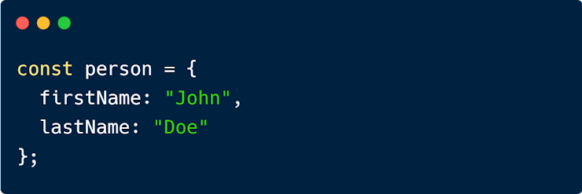

* console.log(person.lastName)
* console.log(person["lastName"]);
* alert(person[lastName]);
* alert(person["lastName"]);
* alert(person.lastName);

1. **What's the output? \***

The Questions can have more than one correct answer.

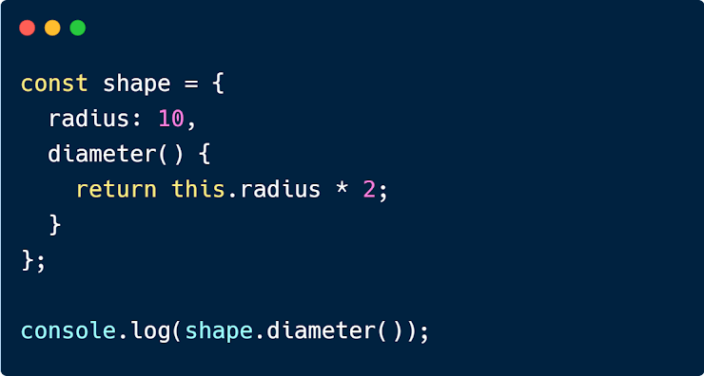

* 30
* 40
* 20.00
* 20

1. **What will be the output of this code? \***

The Questions can have more than one correct answer.

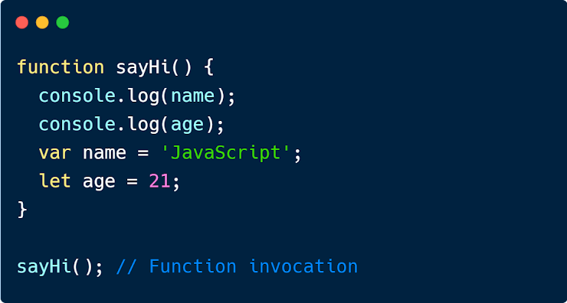

* Syntax Error
* JavaScript and undefined
* undefined and 21
* ReferenceError and 21
* JavaScript and 21
* undefined and ReferenceError

1. **Which statement will log 'Mickey' in console? \***

The Questions can have more than one correct answer.

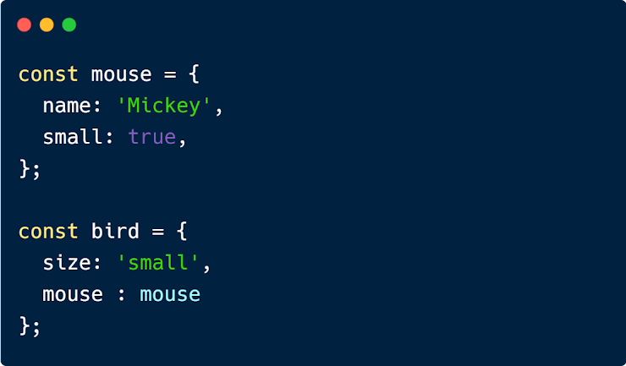

* console.log(bird['mouse']['name'])
* console.log([mouse.name](https://www.google.com/url?q=http://mouse.name&sa=D&source=editors&ust=1643615597937255&usg=AOvVaw31N5qG0okKugOJODKPBPrP));
* console.log([bird.mouse.name](https://www.google.com/url?q=http://bird.mouse.name&sa=D&source=editors&ust=1643615597937587&usg=AOvVaw0ZJ49sSS16APa4-u5KSz6a));
* console.log(mouse['name'])

1. **'this' refers to the _________ of the function \***

The Questions can have more than one correct answer.

* Operators
* expressions
* Strings
* Owner
* Caller Object

1. **What is event in JavaScript? \***

The Questions can have more than one correct answer.

* Game Event
* String Event
* Talk with Sumit Event
* Programming Event
* "things" that happen to HTML Element

1. **Which are valid HTML Event? \***

The Questions can have more than one correct answer.

* onevent
* onlive
* onkeydown
* onclick
* onload

1. **What is the use of \t in a String? \***

The Questions can have more than one correct answer.

* Vertical Tabulator
* New Line
* Backspace
* Horizontal Tabulator

1. **How will you find the size of a string? \***

The Questions can have more than one correct answer.

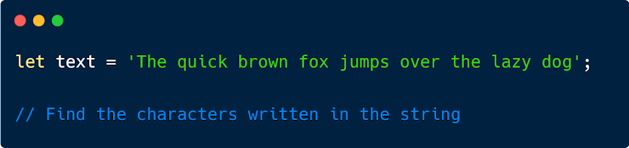

* text.size;
* text.length();
* text.size();
* text.length;

1. **Which method will extract 'Sokina' from the string? \***

The Questions can have more than one correct answer.



* str.slice(11, 18);
* str.substr(11, 18)
* str.substr(-6)
* str.substr(7, 12)
* str.substr(7)

1. **What is the use of \n in a String? \***

The Questions can have more than one correct answer.

* Backspace
* Vertical Tabulator
* Carriage Return
* Creates New Line

1. **What does String.trim () do in JavaScript? \***

The Questions can have more than one correct answer.

* Removes the whitespaces from start of string
* Removes the whitespaces from end of string
* Removes the Blackspace
* Removes the Whitespaces from start and end of string

1. **Which method will extract 'Brown' from the string? \***

The Questions can have more than one correct answer.

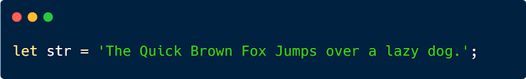

* str.substr(11, 18)
* str.substr(9, 15)
* str.slice(11, 18);
* str.substring(10, 15)
* str.slice(10, 15);

1. **Guess the Output \***

The Questions can have more than one correct answer.

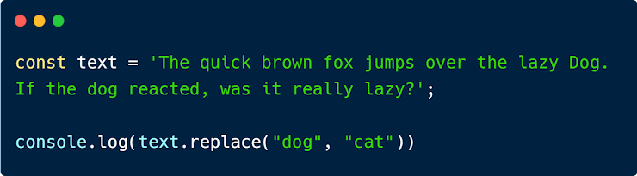

* The quick brown fox jumps over the lazy cat. If the dog reacted, was it really lazy?
* The quick brown fox jumps over the lazy dog. If the dog reacted, was it really lazy?
* The quick brown fox jumps over the lazy cat. If the cat reacted, was it really lazy?
* The quick brown fox jumps over the lazy Dog. If the cat reacted, was it really lazy?

1. **Convert the String of groceries into an array \***

The Questions can have more than one correct answer.



* groceries.split('')
* groceries.split('')
* groceries.split('-')
* groceries.split('|')
* groceries.split(',')

1. **What will be the output? \***



* 7777 // Note: Syntax: string.padStart(targetLength, padString)
* 4444447 // This type of padding is sometimes called *left pad* or *lpad*
* 77777
* 7774

1. **Guess the Output \***

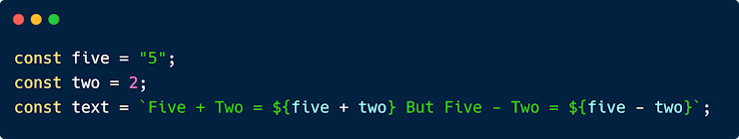

* Five + Two = five + two But Five - Two = five - two
* Five + Two = 7 But Five - Two = 52
* Five + Two = 52 But Five - Two = 3

1. **What is the difference between double equal and tripple equal in JavaScript? \***

The Questions can have more than one correct answer.

* Double equal only compares the value but tripple equal compares value and data type.

1. **JavaScript has distinct types for numbers like int, float, etc. Is it True or False? \***

* True
* False

1. **typeof NaN returns a - \***

* number

1. **What will be the output of this code? \***

The Questions can have more than one correct answer.

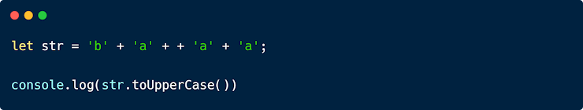

* BAAA
* BA1AA
* BAAAA
* BANANA

1. **What is the length of fastFood array? \***

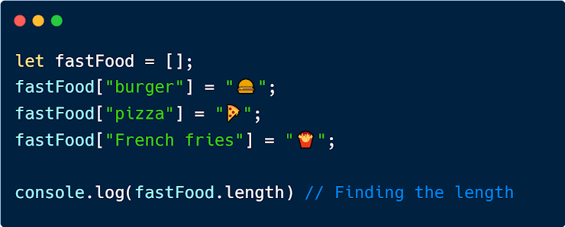

* 1
* 5
* 3
* 4
* 0

1. **What will be the correct output? \***

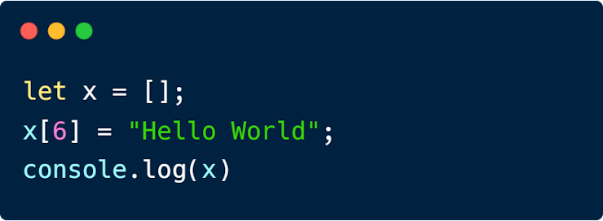

* [null, null, null, null, null, "Hello World"]
* ["Hello World"]
* ["undefined", " undefined", " undefined", " undefined", " undefined", " undefined", "Hello World"]

1. **What is an Array? \***

The Questions can have more than one correct answer.

* Sequence of Numbers
* Combination of Arithmetic Operators
* Sequence of Characters
* Collection of Elements

1. **How would you access the last element from the array? \***

The Questions can have more than one correct answer.

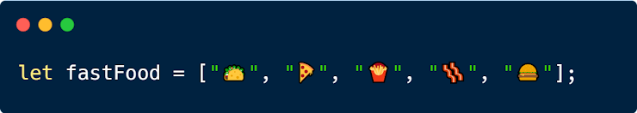

* fastFood[ fastFood.size - 1];
* fastFood[ fastFood.size() - 1];
* fastFood[ fastFood.length];
* fastFood[ fastFood.length() - 1];
* fastFood[ fastFood.length - 1];

1. **How would you extract "" from the array list ? \***

The Questions can have more than one correct answer.



* console.log(fastFoods[fastFood.length]);
* console.log(fastFoods[4]);
* console.log(fastFood[fastFood.indexOf("")]);
* console.log(fastFood[4]);
* alert(fastFood[4]);

1. **How would you remove the first or the last element from the array? \***

The Questions can have more than one correct answer.

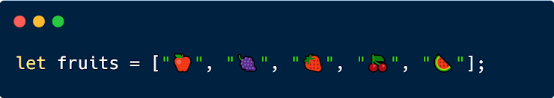

* fruits.push()
* fruits.remove()
* fruits.unshift()
* fruits.shift() // First
* fruits.pop(); // Last

1. **How would you remove  and  ? \***

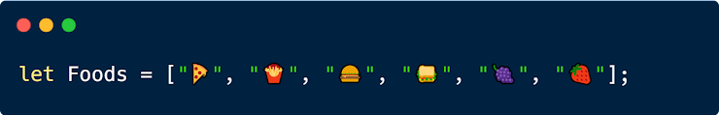

* Foods.splice(3,-1);
* Foods.splice(2,3);
* Foods.splice(3,4);
* Foods.splice(2,2);

1. **How would you replace "" with "" ? \***

The Questions can have more than one correct answer.



* fruits.replace("") = "";
* fruits[3] = "";
* fruits.shift("") = "";
* fruits[ fruits.indexOf("") ] = "";
* fruits[2] = "";

1. **Convert the fruits array to a comma separated String - \***

The Questions can have more than one correct answer.



* fruits.arrayToString()
* fruits.join("-")
* fruits.join(",")
* fruits.toString();
* fruits.join()

1. **Guess the Output \***

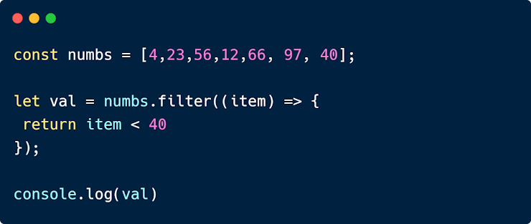

* 4, 23, 12, 40
* 4, 23, 12
* [4, 23, 12, 40]
* [4, 23, 12]

1. **How will you find the highest number from this array? \***

The Questions can have more than one correct answer.



* arr.sort(function(a, b){return a + b})
* arr.sort(function(a, b){return b - a})
* math.max.apply(null, arr);
* Math.min.apply(null, arr);
* Math.max.apply(null, arr);
* arr.sort(function(a, b){return b - a})[0]

1. **What is the third parameter of forEach Function? \***

* External Array
* Undefined
* Item Index
* Item Value
* Array Itself

1. **What is the purpose of "Array.includes()"? \***

The Questions can have more than one correct answer.

* It push a new value to the array
* 4, 23, 12, 40
* Array.includes() method checks if the value is existing in the array

1. **Sort the fruits array alphabetically in descending order \***

The Questions can have more than one correct answer.

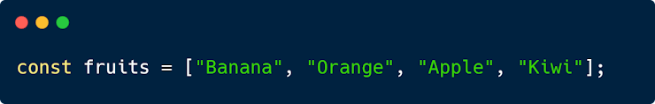

* fruits.sort().desending();
* fruits.sort();
* fruits.sort(function(a,b) {return a-b});
* fruits.sort().reverse();

1. **Sort the fruits array alphabetically in ascending order \***

The Questions can have more than one correct answer.



* fruits.sort(function(a,b) {return a-b});
* fruits.sort().desending();
* fruits.sort().reverse();
* fruits.sort();

1. **What is the return value of 'forEach' and 'map' method? \***

* array and array
* null and array
* nothing & array
* undefined and undefined
* undefined and array

1. **What will be the output of this question? \***

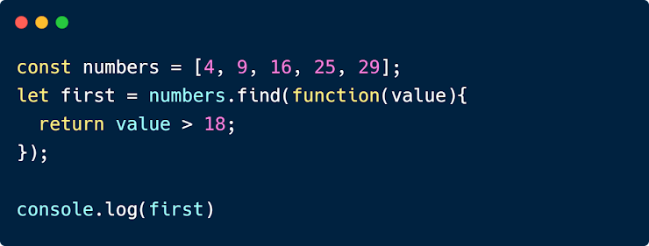

* [25, 29]
* 25, 29
* [25]
* 25

1. **Which method is used to convert date to milliseconds? \***

* Date.milli()
* Date.int.parse();
* Date.miisecond();
* Date.parse()

1. **Guess the Output \***

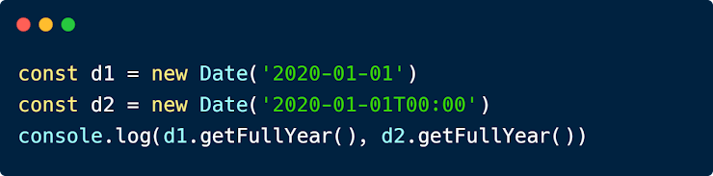

* 2020, 2020
* 2020, 2021
* 2021, 2020
* 2021, 2021

1. **How would you print current date? \***

The Questions can have more than one correct answer.

* console.log(new Date.now());
* console.log(new Date().now());
* alert(new Date());
* console.log(new Date());

1. **What is the return value of - Math.round(1.499); \***

* 1
* 1.5
* 1.4
* 2

1. **What is the purpose of Math.random(); \***

The Questions can have more than one correct answer.

* Generate Random Number.

1. **Which is the correct code for generating absolute random number between 1-100? \***

The Questions can have more than one correct answer.

* Math.Random()
* Math.random() * 100 + 1
* Math.floor(Math.Random() * 100) + 1
* Math.floor(Math.random() * 100) + 1

1. **What is the purpose of Math.abs(); \***

The Questions can have more than one correct answer.

* Returns Absolute Value
* Returns Positive Value
* Returns six pack abs

1. **What Math.ceil() method does? \***

The Questions can have more than one correct answer.

* Rounds a number up to the next largest integer
* Returns the integer part of a number by removing any fractional digits
* Returns the largest integer less than or equal to a given number

1. **If the Score is 15, what will be the output of this code? \***

The Questions can have more than one correct answer.

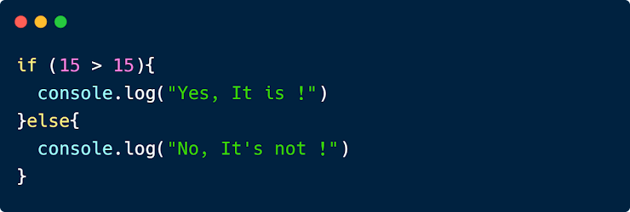

* Yes, It is !
* No, It's not !

1. **What will be the output of this code? \***

The Questions can have more than one correct answer.

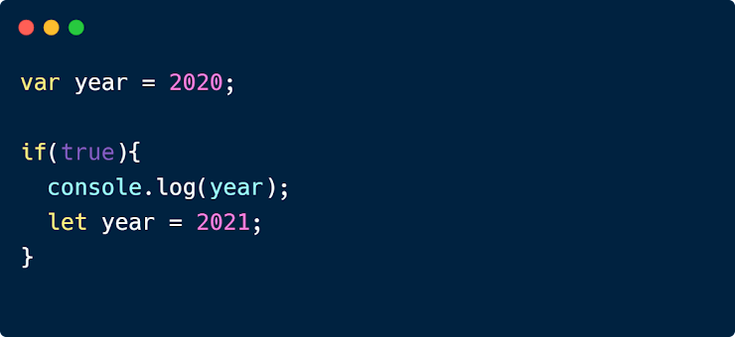

* Undefined
* 2021
* ReferenceError

1. **What will be the output of this code? \***

The Questions can have more than one correct answer.

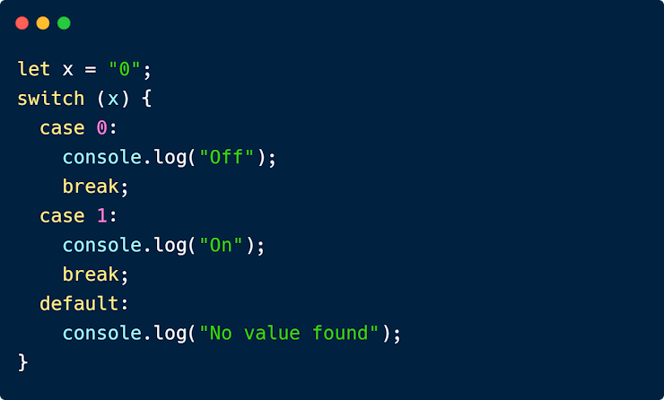

* undefined
* Off
* Reference Error
* No Value Found

1. **When the 'if' block of code will be executed? \***

The Questions can have more than one correct answer.

* When the Condition is True
* When the Condition is not False

1. **If the Score is 15, what will be the output of this code? \***

The Questions can have more than one correct answer.

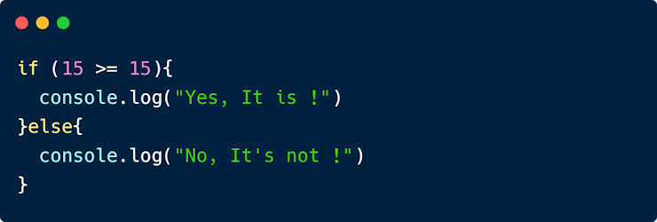

* Yes, It is !
* No, It's not !

1. **When the 'else' block of code will be executed? \***

The Questions can have more than one correct answer.

* When the Condition is False

1. **If the Score is 15, what will be the output of this code? \***

The Questions can have more than one correct answer.

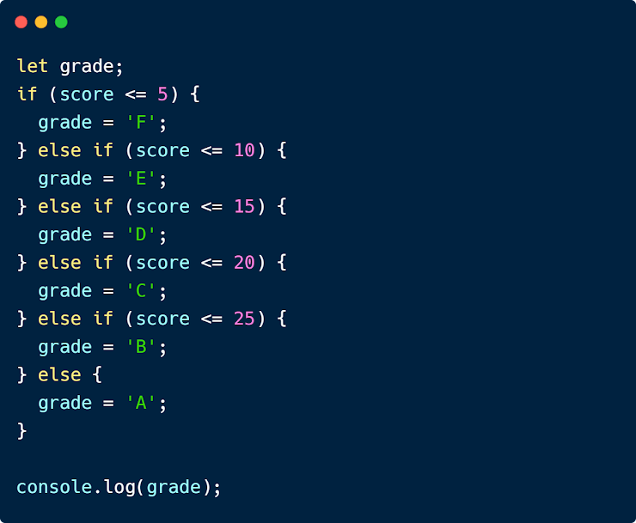

* B
* C
* Undefined
* ReferenceError
* E
* A
* D

1. **What will be the output of this code? \***

The Questions can have more than one correct answer.

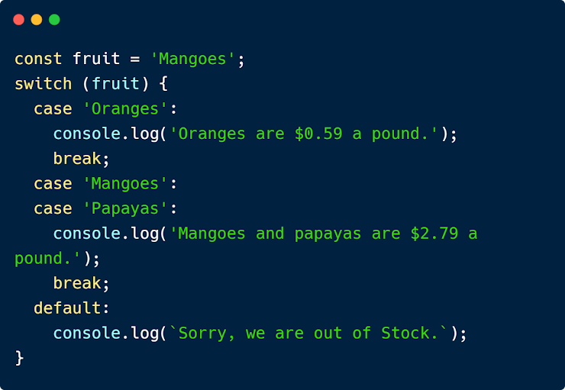

* Oranges are $0.59 a pound.
* null
* undefined
* Sorry, we are out of Stock.
* Reference Error
* Mangoes and papayas are $2.79 a pound.

1. **As a Coder, What is the first thing you should do when you are stuck on a problem? \***

The Questions can have more than one correct answer.

* Post On Facebook groups and Ask for help
* Search for the Solution on Netflix
* Stop Coding and Watch Movie
* Ask Community Facebook group
* Search for the Solution on Google

1. **If the Score is 15, what will be the output of this code? \***

The Questions can have more than one correct answer.



* Undefined
* No, It's not !
* ReferenceError
* Yes, It is !

1. **In this code `this` refers to - \***

The Questions can have more than one correct answer.

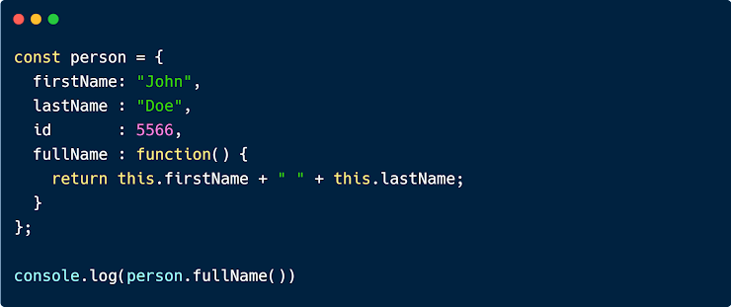

* Methods of the Object
* All the Methods
* Properties of the Object
* Owner of the Function
* Person Object

1. **Which function will reorganize the array from the end to the start? \***

The Questions can have more than one correct answer.

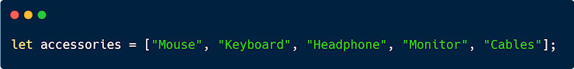

* accessories.sort();accessories.shift();
* accessories.reorganize();
* accessories.compile();
* accessories.push();
* [accessories.re](https://www.google.com/url?q=http://accessories.re&sa=D&source=editors&ust=1643620845193888&usg=AOvVaw0hsILfUhpCDK9DqkZMge0F)();
* accessories.reverse();

1. **What will be the output of this code? \***

The Questions can have more than one correct answer.

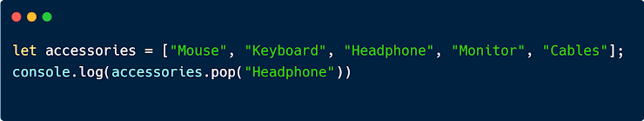

* Headphone
* Keyboard
* Monitor
* Mouse
* Cables

1. **Why 'break' statement is used in a loop? \***

The Questions can have more than one correct answer.

* Skip Current Iteration
* To Jump Over one Iteration
* Immediately terminate Current Loop
* To Jump Out from a loop

1. **Which statement will skip only current Iteration? \***

The Questions can have more than one correct answer.

* break
* skip
* continue

1. **Guess the Output - \***

The Questions can have more than one correct answer.



* string
* A Object
* Array
* Undefined
* Number

1. **What is the type of an Array? \***

The Questions can have more than one correct answer.

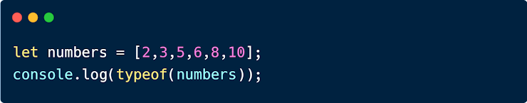

* Number
* Undefined
* Array
* String
* A Object

1. **Type of 'NaN' (Not a Number) is a - \***

The Questions can have more than one correct answer.

* String
* A Object
* Undefined
* Array
* Number

1. **Return value of 'typeof' could be - \***

The Questions can have more than one correct answer.

* A Object
* String
* Boolean
* Number
* Date
* Undefined
* Array

1. **'typeof' is a - \***

The Questions can have more than one correct answer.

* Function
* Method
* Property
* Variable
* Attribute
* Statement
* Operator

1. **'typeof' a function is a - \***

The Questions can have more than one correct answer.

* undefined
* array
* object
* string
* function

1. **How would you Generate Random Numbers -\***

The Questions can have more than one correct answer.

* Math.random();
* Math.Random;
* Math.Random();
* Math.random;

1. **How Can You Convert a Number to a String\***

The Questions can have more than one correct answer.

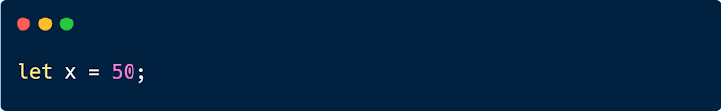

* ++x
* x+
* x.toInt()
* String(x);
* x.toString();
* x+""

1. **Guess the Output - \***

The Questions can have more than one correct answer.



* Reference Error
* undefined
* false
* true

1. **What will be the output? \***

The Questions can have more than one correct answer.

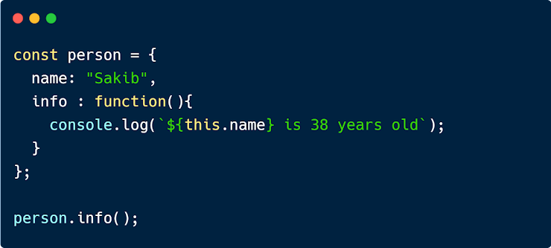

* name is 38 years old
* `${[this.name](https://www.google.com/url?q=http://this.name&sa=D&source=editors&ust=1643620977804116&usg=AOvVaw0TX6eHxtHt0uQ1RwjNIzee)} is 38 years old`
* [this.name](https://www.google.com/url?q=http://this.name&sa=D&source=editors&ust=1643620977804420&usg=AOvVaw3L2GBJiqqQwRxGw1Nzwj6q) is 38 years old
* Sakib is 38 years’ old

1. **How Can You Convert a String to a Number \***

The Questions can have more than one correct answer.

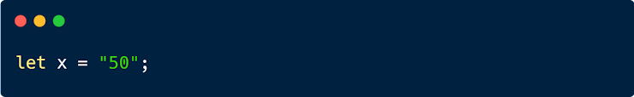

* x.parseInt();
* x.toInt()
* x+
* +x;
* parseInt(x);

1. **In case of JavaScript Throw Statement, what does JavaScript throws? \***

The Questions can have more than one correct answer.

* An Error
* Exception
* String
* A Book
* Undefined
* Null

1. **What is the difference between Array and Set? \***

The Questions can have more than one correct answer.

* Set contains unique values but Array can contain duplicate values
* Set can contain only String Data type but Array can contain all data types
* Array can contain unlimited values but Set contains only limited contain
* Array and Set is same thing

1. **Purpose of 'catch' Statement is - \***

The Questions can have more than one correct answer.

* Catch the Virus
* Create Custom Error
* Throw the Error
* Handle the Error

1. **Which one will return true? \***

The Questions can have more than one correct answer.

* Number('Hello Peter');
* Boolean()
* isNaN('123')
* Boolean({});
* isNaN('Hello Peter');

1. **let & const provide - \***

The Questions can have more than one correct answer.

* Undefined Scope
* Functional Scope
* Global Scope
* Block Scope

1. **If we declare a variable, let test = 1, then later, reassign, stating test == 2, what will happen? \***

The Questions can have more than one correct answer.

* JS will raise a TypeError
* test will equal undefined
* test will equal to 2
* test will equal to 1

1. **This will log "Volvo" in the console, But why? \***

The Questions can have more than one correct answer.

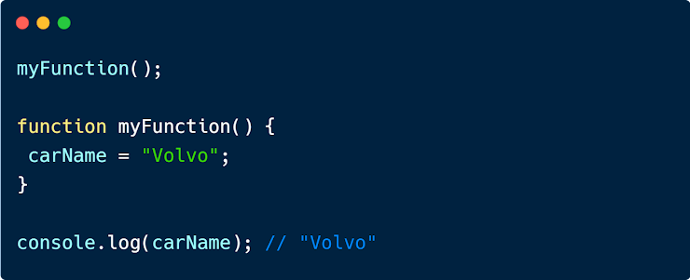

* Because of Block Scope
* This is the Feature of Modern Browser
* This is the rule of Functional Scope
* Variable Assigned but Not declared
* Keyword of the variable is not defined

1. **Variables declared Globally can accessible from \***

The Questions can have more than one correct answer.

* Global Scope
* Block Scope
* Functional Scope
* Any Where in the Program

1. **What is scope in JavaScript? \***

The Questions can have more than one correct answer.

* Availability of variables in a certain area
* Accessibility of variables.
* Particular Zone where variables are available

1. **Why let and const are not similar? \***

* let cannot be reassigned, const can be reassigned
* let is block scope, while const is functional scope
* let is the new feature of es6 but const is old feature of ECMA Script
* let can be reassigned but const can't be reassigned

1. **What will be the output of this code? \***

The Questions can have more than one correct answer.

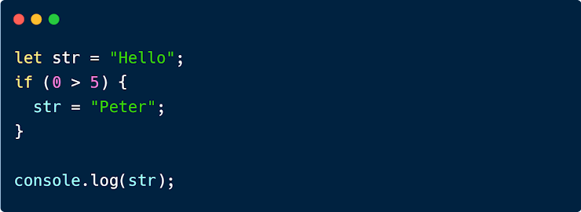

* undefined
* null
* Peter
* Hello

1. **Guess the Output - \***

The Questions can have more than one correct answer.

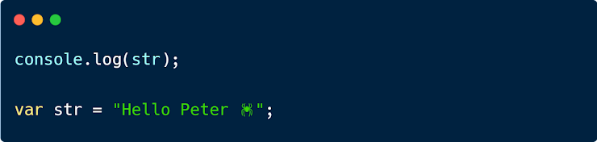

* undefined
* Hello Peter Reference Error
* Undefined
* Hello Peter 🕷
* Hello Peter XX
* Reference Error

1. **Guess the Output - \***

The Questions can have more than one correct answer.

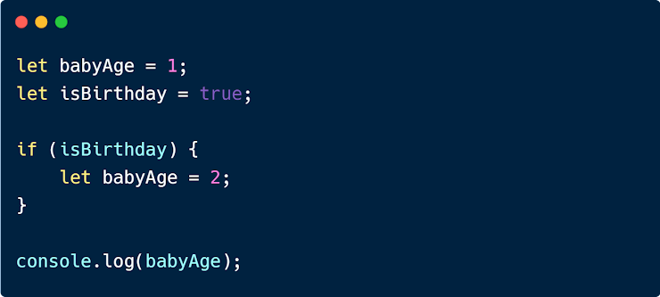

* Reference Error
* 2
* 3
* Undefined
* 1

1. **What is temporal dead zone? \***

The Questions can have more than one correct answer.

* State of a variable until it is declared
* Where Variables value become Zero
* Situation when program gets crushed
* Similar to Area 51

1. **What JavaScript hoisting does? \***

The Questions can have more than one correct answer.

* Move the Declarations to the top
* Convert Variable value to Undefined
* Move a variable to the top
* Capture a variable into a block
* Block a variable

1. **What will be the output of this code? \***

The Questions can have more than one correct answer.

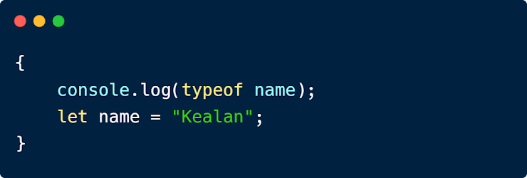

* String
* null
* "Kealan"
* Kealan
* Undefined
* ReferenceError

1. **"this" keyword refers to - \***

The Questions can have more than one correct answer.

* Global object
* Owner object

1. **In the calculateBMI function 'this' keyword refers to - \***

The Questions can have more than one correct answer.

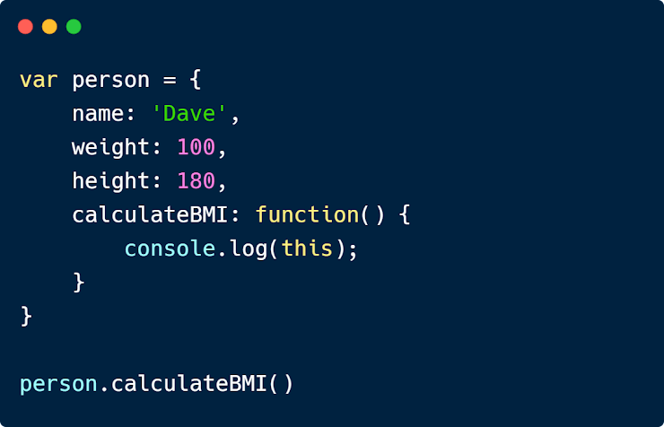

* Global Object
* undefined
* Block Object
* Owner of the Method
* person Object

1. **"use strict" is a - \***

The Questions can have more than one correct answer.

* Operation
* Variable
* Object
* Syntax
* Statement
* Literal Expression

1. **Which are true about "use strict" - \***

The Questions can have more than one correct answer.

* Undeclare Variables
* Introduced in ECMAScript 5
* Write Secure JavaScript
* Execute code in Strict Mode

1. **"this" is a - \***

The Questions can have more than one correct answer.

* Literal Expression
* Syntax
* Statement
* Variable
* Object
* Operation
* Keyword

1. **Arrow function provide us to write - \***

The Questions can have more than one correct answer.

* functions in strict mode
* Scope less function
* Big Function
* shorter function syntax
* concise way to write functions

1. **Arrow Function and Normal Function handle 'this' differently \***

The Questions can have more than one correct answer.

* True
* False

1. **When did Arrow Function introduced? \***

The Questions can have more than one correct answer.

* 2015

1. **Guess the Output - \***

The Questions can have more than one correct answer.

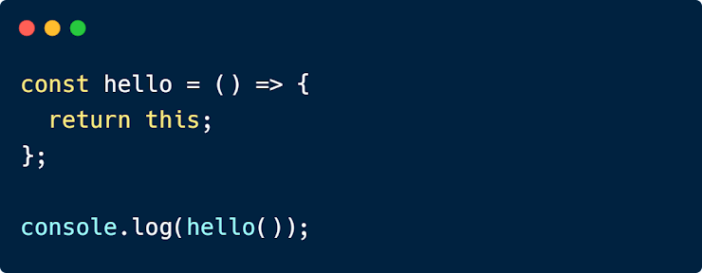

* Undefined
* Function Body
* Function Object
* Window object

1. **Guess the Output - \***

The Questions can have more than one correct answer.

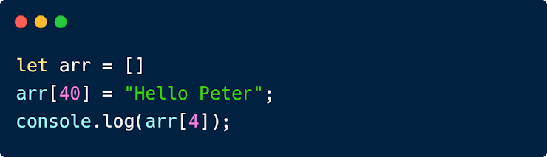

* Empty
* Reference Error
* Hello Peter
* Null
* undefined

1. **What is Class in JavaScript? \***

The Questions can have more than one correct answer.

* JavaScript Object
* Alternative of Object
* Object Property
* Template for JavaScript Object

1. **Which keyword is used to create a class - \***

The Questions can have more than one correct answer.

* Classes
* constructor
* classes
* class

1. **How do you convert a JSON String to JSON? \***

The Questions can have more than one correct answer.

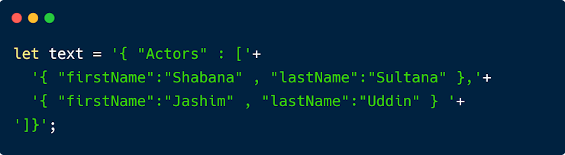

* JSON.toStr(text)
* String.toJSON(text)
* JSON(text)
* JSON.parse(text)

1. **How do you remove 'Prince' property from this object? \***

The Questions can have more than one correct answer.

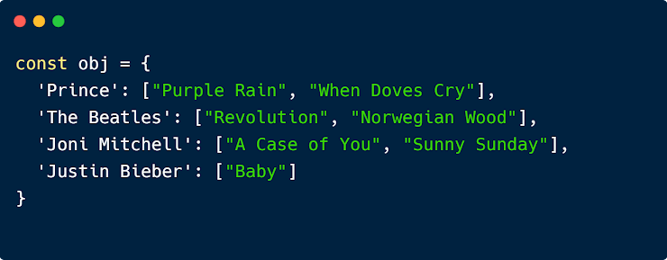

* remove obj["Prince"]
* obj["Prince"].delete()
* obj["Prince"].remove()
* delete obj["Prince"]

1. **Which is the correct way to add new property to this object? \***

The Questions can have more than one correct answer.



* obj['Daft Punk'] = ["Harder, Better, Faster, Stronger"];
* obj.push('Daft Punk' : ["Harder, Better, Faster, Stronger"]);
* obj = {...obj, {'Daft Punk' : ["Harder, Better, Faster, Stronger"]}}
* obj.add('Daft Punk' : ["Harder, Better, Faster, Stronger"]);

1. **JSON data is a pair of - \***

The Questions can have more than one correct answer.

* Comma and Semi Colon
* Curly braces and Square braces
* Object and Array
* Name and Value

1. **JSON stands for - \***

The Questions can have more than one correct answer.

* JavaScript Operation Management
* Java Source Open Network
* Java Specified Object Notation
* JavaScript Object Notation

1. **Which keyword stops the execution of JavaScript? \***

The Questions can have more than one correct answer.

* debugger
* tool
* stop
* pause
* dev

1. **What represents 'console' in the 'console.log()' method? \***

The Questions can have more than one correct answer.

* Program
* Subject
* Hackers Tools
* Game Console
* Object

1. **With a debugger breakpoints helps to - \***

The Questions can have more than one correct answer.

* Stop execution
* Remove Bug
* Start execution
* Fix Bug
* Release Debugging

1. **In a function how many break point we can use? \***

The Questions can have more than one correct answer.

* Many
* Three
* Two
* One
* Four

**// Note:** You can set up to 30 dynamic breakpoints without changing the program code

1. **console.log method used to display - \***

The Questions can have more than one correct answer.

* Output
* Values
* Errors

1. **Which build-in debugger is available in all modern browsers? \***

The Questions can have more than one correct answer.

* ECMAScript
* JavaScript
* Python and javascript
* C++
* None of the above

1. **How do you round the number 100.495 to nearest integer? \***

The Questions can have more than one correct answer.

* Math.trunc(100.495);
* Math.int(100.495);
* Math.round(100.495);
* Math.floor(100.495);

1. **Guess the Output \***

The Questions can have more than one correct answer.

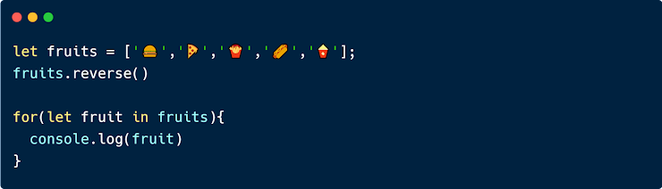

* 
* 4 3 2 1 0
* 
* 0 1 2 3 4 // Note: ***for in*** use for object iteration

1. **Guess the Output \***

The Questions can have more than one correct answer.

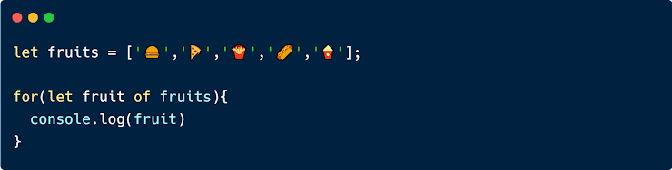

* 
* 1 2 3 4 5
* 
* 0 1 2 3 4

1. **What is the correct way to write a JavaScript Array? \***

The Questions can have more than one correct answer.

* let colors = [blue, red, green];
* let colors = {'blue', 'red', 'green'};
* let colors = Array('blue', 'red', 'green');
* let colors = ['blue', 'red', 'green'];

1. **Fill in the blank \***

The Questions can have more than one correct answer.

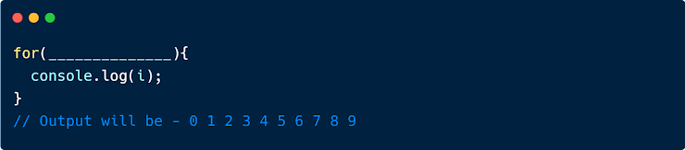

* let i = 0; i< 10; i++
* i = 0; i< 10; i++
* let i = 0; i=< 10; i++
* let i = 0, i< 10, i++
* let i = 1; i< 10; i++

1. **How Many statements are needed for a "For Loop"? \***

The Questions can have more than one correct answer.

* 3
* 1
* 4
* 2

1. **What is the output of this code? \***

The Questions can have more than one correct answer.

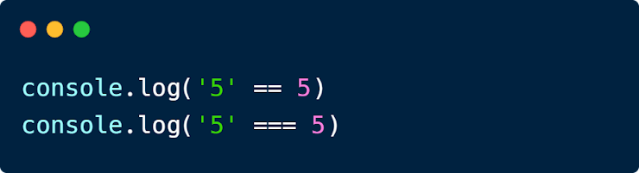

* true, undefined
* false, true
* undefined, false
* true, true
* false, undefined
* false, false
* true, false

1. **Which statement is true for Let? \***

The Questions can have more than one correct answer.

* Assign Expressions to some variable
* Assign Operators to a variable
* Let Provides Block scope
* let variables cannot be re-declared

1. **What is the purpose of Assignment operator? \***

The Questions can have more than one correct answer.

* Assign Operators to a variable
* Assign Expressions to some variable
* Assign values to a Boolean
* Assign values to variables

1. **What are logical operators? \***

The Questions can have more than one correct answer.

* ?
* ===
* <=
* &&
* ||
* !

1. **What is the output of Boolean(undefined)? \***

The Questions can have more than one correct answer.

* false
* off
* on
* yes
* no
* true

1. **What are the possible values of Boolean Data Type? \***

The Questions can have more than one correct answer.

* yes
* no
* on
* off
* true
* false

1. **JavaScript Sets - \***

The Questions can have more than one correct answer.

* is a collection of unique values.
* can hold any value of any data type.
* Each value can only occur once
* none of the above

1. **How to Create a Set? \***

The Questions can have more than one correct answer.

* Passing an Array to new Set()
* Create a new Set and use add() to add values
* Create a new Set and use add() to add variables

1. **Which method can also be used to change existing Map values? \***

The Questions can have more than one correct answer.

* sets()
* get()
* has()
* set()

1. **The size property returns __________ of elements in a Map. \***

The Questions can have more than one correct answer.

* number
* quantum
* value
* Length

1. **How to Create a Map? \***

The Questions can have more than one correct answer.

* Create a Map and use Map.sets()
* Passing an Array to new.Map()
* Passing an Array to new Map()
* Create a Map and use Map.set()

1. **Which method returns true if a key exists in a Map? \***

The Questions can have more than one correct answer.

* sets()
* get()
* set()
* has()

1. **Triple Equal (===) operator compares - \***

The Questions can have more than one correct answer.

* Function
* Argument
* Parameter
* Data Type
* Data Value

1. **What is the best practice of treating Numbers, Strings, or Booleans? \***

The Questions can have more than one correct answer.

* Boolean
* Function
* Object
* Array
* Primitive Value

1. **What should you do when JavaScript Statement doesn't fit on One line? \***

The Questions can have more than one correct answer.

* Break the Line and Separate with Camel case Letter
* Break the Line and Separate with Operator
* Stop Coding
* Break your Computer
* Break the Line and Separate with Comma

1. **What is the best practice to end switch statements? \***

The Questions can have more than one correct answer.

* Case
* Switch
* Break
* Function
* Default

1. **Subtracting a string from a string, what does it generate? \***

The Questions can have more than one correct answer.

* undefined
* Number
* String
* Not a Number

1. **What will be the output/return value of myFunction()? \***

The Questions can have more than one correct answer.

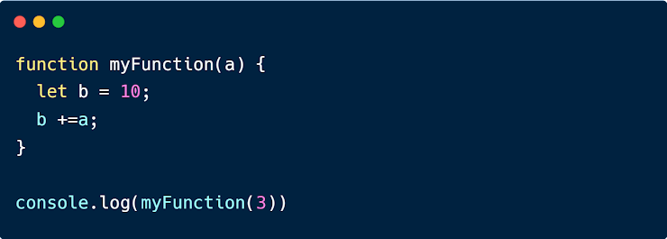

* null
* 3
* 10
* Empty
* 13
* NaN
* Undefined // Note: function return missing

1. **In JavaScript + operator use to - \***

The Questions can have more than one correct answer.

* Add Numbers
* Concatenate Strings
* Add Strings

1. **Does JavaScript support arrays with Named Index? \***

The Questions can have more than one correct answer.

* true
* false // Note: JavaScript does not support arrays with named indexes.

1. **All numbers in JavaScript are stored as - \***

The Questions can have more than one correct answer.

* 32-bits decimal numbers
* 64-bits decimal numbers
* 32-bits Floating point numbers
* 64-bits Floating point numbers

1. **What will be the return value of myFunction()? \***

The Questions can have more than one correct answer.

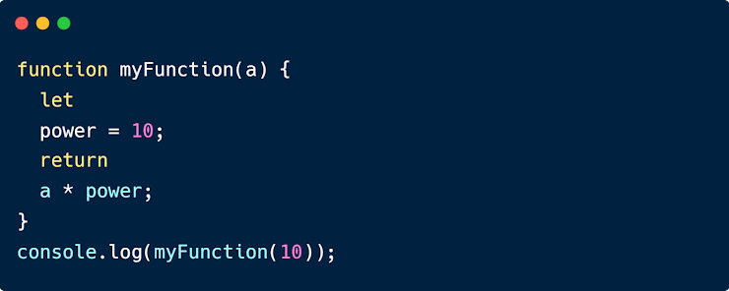

* undefined
* Empty
* null
* 100000000
* NaN
* a * power
* 10000000000

1. **Primitive data types are - \***

The Questions can have more than one correct answer.

* number
* string
* boolean
* null
* undefined
* symbol

1. **Objects are variables? \***

The Questions can have more than one correct answer.

* true
* false

1. **A null "value" is always - \***

The Questions can have more than one correct answer.

* undefined
* function
* object
* null

1. **A primitive value has no - \***

The Questions can have more than one correct answer.

* value
* methods
* properties

1. **Objects can be created by - \***

The Questions can have more than one correct answer.

* Create a single object, using an object literal.
* Create a single object, with the keyword new.
* Define an object constructor, and then create objects of the constructed type.
* Create an object using Object.create().

1. **Which are objects in javascript? \***

The Questions can have more than one correct answer.

* Regular expressions
* Math
* Date
* new Numbers

1. **A JavaScript object is a collection of __________ properties. \***

The Questions can have more than one correct answer.

* unordered
* new
* ordered
* array

1. **In JavaScript objects the delete keyword deletes? \***

The Questions can have more than one correct answer.

* Deletes both the value of the property and the property itself.
* the value of the property
* the property itself

1. **How can we access nested objects using the dot notation or the bracket notation? \***

The Questions can have more than one correct answer.

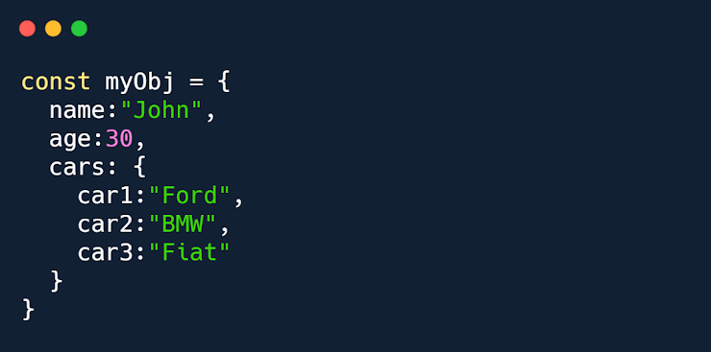

* myObj.cars["car2"];
* myObj["cars"]["car2"];
* myObj.cars.car2;

1. **Properties can usually be - \***

The Questions can have more than one correct answer.

* added
* deleted
* some are read only
* only the value attribute can be changed
* changed, added, and deleted, but some are read only.

1. **The syntax for accessing the property of an object is? \***

The Questions can have more than one correct answer.

* objectName[expression]
* objectName["property"]
* objectName.property
* objectName["value"]

1. **The JavaScript _________ statement loops through the properties of an object. \***

The Questions can have more than one correct answer.

* do...while
* for...of
* switch
* for...in

1. **How can we capitalize the all word. \***

The Questions can have more than one correct answer.

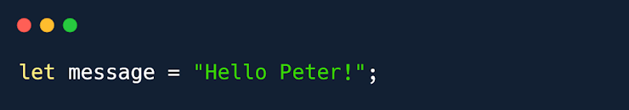

* Message.toUpperCase();
* message.ToUpperCase();
* message.toUppercase();
* message.toUpperCase();

1. **JSON.stringify converts dates into - \***

The Questions can have more than one correct answer.

* strings
* numbers
* undefined
* json

1. **How can we display JavaScript objects properly -\***

The Questions can have more than one correct answer.

* using Object.values()
* Properties in a Loop
* using JSON.stringify()
* Properties by name

1. **Displaying a JavaScript object will output the - \***

The Questions can have more than one correct answer.

* value
* [object Object]
* Displaying a JavaScript object will output [object Object]

1. **JavaScript methods are actions that can be performed on - \***

The Questions can have more than one correct answer.

* objects
* functions
* array
* JavaScript methods are actions that can be performed on objects

1. **Which is faster? \***

The Questions can have more than one correct answer.

* new String()
* new Function()
* Use string literals "" instead of new String().
* Use pattern literals /()/ instead of new RegExp()

1. **The new keyword can be used on Math? \***

The Questions can have more than one correct answer.

* No
* Yes

1. **JavaScript has built-in constructors for native objects are - \***

The Questions can have more than one correct answer.

* new String() // A new String object
* new Number() // A new Number object
* new Boolean() // A new Boolean object
* new Object() // A new Object object
* new Array() // A new Array object
* new RegExp() // A new RegExp object
* new Function() // A new Function object
* new Date() // A new Date object

1. **What is the typeOf x? \***

The Questions can have more than one correct answer.

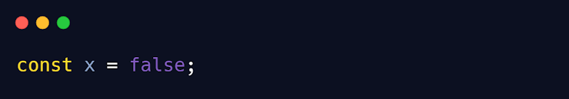

* numbers
* String
* Object
* Boolean

1. **What is the typeOf firstName? \***

The Questions can have more than one correct answer.

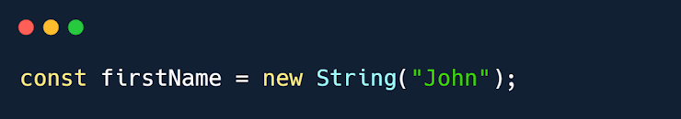

* numbers
* String
* Undefined
* Object

1. **What will be the output? \***

The Questions can have more than one correct answer.

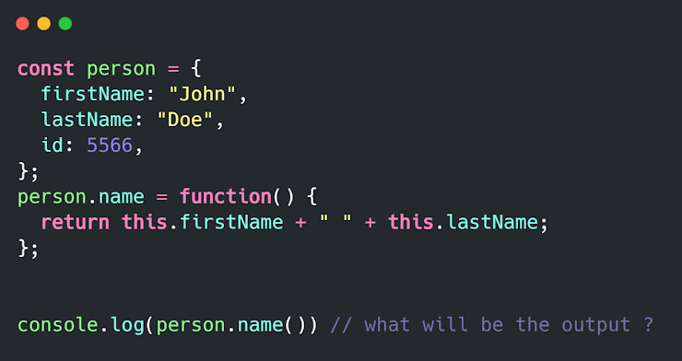

* undefined
* We can not add a new property to an existing object
* TypeError
* null
* John Doe

1. **How will you print 'Elon Musk' from the Object? \***

The Questions can have more than one correct answer.

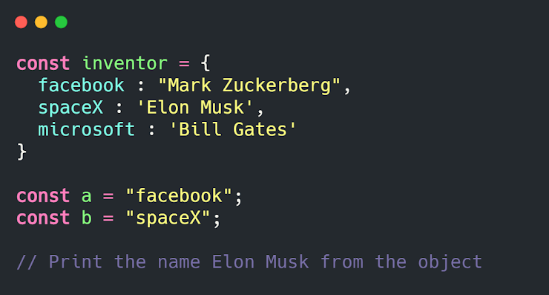

* inventor['b']
* inventor[spaceX]
* inventor.b
* inventor[b]
* inventor['spaceX']

1. **What happens when we do this? \***

The Questions can have more than one correct answer.

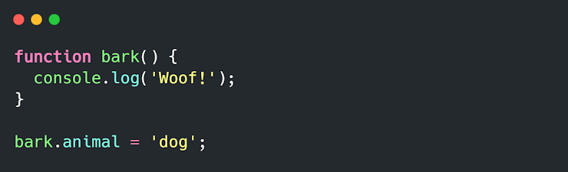

* SyntaxError. You cannot add properties to a function this way.
* ReferenceError
* "Woof" gets logged.
* Nothing, this is totally fine!

1. **Guess the Output \***

The Questions can have more than one correct answer.

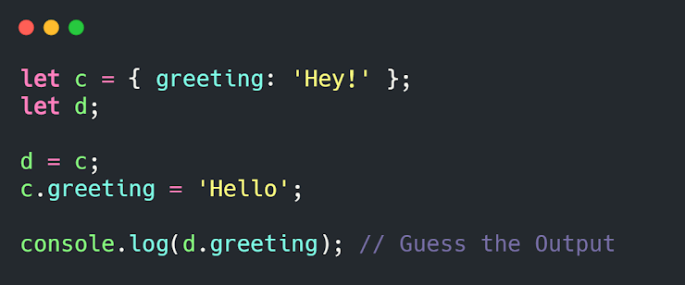

* TypeError
* ReferenceError
* Hey!
* Undefined
* Hello

1. **What is the output of this code? \***

The Questions can have more than one correct answer.

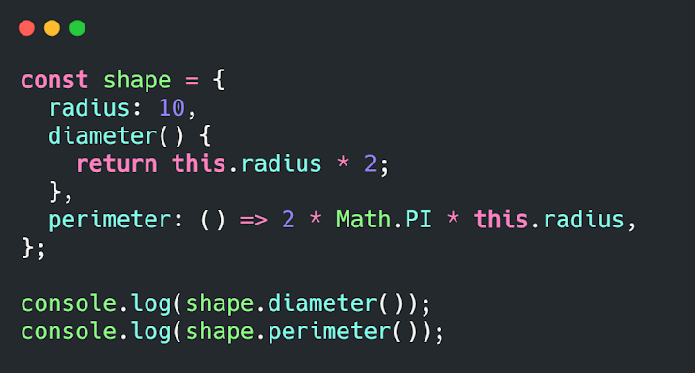

* NaN and 63
* 20 and NaN
* 20 and 62.83185307179586
* 20 and 63

1. **What is the default return value of a function? \***

The Questions can have more than one correct answer.

* undefined
* null
* empty
* blank

1. **What is the type of a function? \***

The Questions can have more than one correct answer.

* function
* Array
* undefined
* Object
* Null

1. **JS Functions are defined with the keyword - \***

The Questions can have more than one correct answer.

* function
* functions
* method
* def
* fun

1. **When function does not hoisted? \***

The Questions can have more than one correct answer.

* when we don't invoke a function
* function declaration never hoisted
* when we use semi-clone at the end of function definition
* When the function is written as Arrow Function
* When Function is defined using expression

1. **In JavaScript Function is an - \***

The Questions can have more than one correct answer.

* Null
* Array
* Function
* Argument
* Undefined
* Object

1. **A function without a name is called \***

The Questions can have more than one correct answer.

* Undefined Function
* Invoke Function
* Null Function
* Unknown Function
* Anonymous Function

1. **What are the difference between Function Parameters & Arguments? \***

The Questions can have more than one correct answer.

* Arguments are invoked but Parameters are called
* Parameters are listed in function definition & Arguments are actual Value
* Arguments are Passed by Value & Parameters are Passed by Reference

1. **Default Value of a Parameter is - \***

The Questions can have more than one correct answer.

* String
* Number
* Argument
* Undefined

1. **When a function is called without an owner object, what will be the value of `this`? \***

The Questions can have more than one correct answer.

* external object
* method object
* parameter object
* arguments object
* window object

1. **What is the purpose of call()? \***

The Questions can have more than one correct answer.

* With the call() method, you can write a method that can be used on different objects.
* With call(), an object can use a method belonging to another object.
* call() method is a predefined JavaScript method
* call() method can accept arguments

1. **Which are true about call() & apply() ? \***

The Questions can have more than one correct answer.

* The call() method takes arguments separately.
* The apply() method takes arguments as an array.

1. **Which one is the build in object of a function? \***

The Questions can have more than one correct answer.

* method object
* parameter object
* window object
* external object
* arguments object

1. **What is the name of the method that should be added to a class? \***

The Questions can have more than one correct answer.

* Class
* Template Literals
* Number
* object
* constructor

1. **When the constructor method is called? \***

The Questions can have more than one correct answer.

* When the object is removed
* When the object is logged in the console
* when the method is called
* when a new object is created.

1. **JavaScript Classes are templates for - \***

The Questions can have more than one correct answer.

* Template Literals
* String
* Number
* Class
* Object
* JavaScript Classes are templates for JavaScript Objects

1. **Which one is true about the Constructor Method? \***

The Questions can have more than one correct answer.

* Constructor executed automatically
* We can change the method name
* We don't need the Constructor method
* Constructor method is optional

1. **Which keyword is used to create class inheritance? \***

The Questions can have more than one correct answer.

* inheritance
* super
* class
* inherit
* extends

1. **Why we should declare a class before using it? \***

The Questions can have more than one correct answer.

* It is the default rule of class
* Because we are using Constructor Method in the class
* Cause class declarations are hoisted
* Cause class declarations are not hoisted

1. **The super() method refers to the - \***

The Questions can have more than one correct answer.

* Object of the Class
* Class
* Constructor Method
* Parent Function
* Current class
* Parent class

1. **Static Class method cannot be called on - \***

The Questions can have more than one correct answer.

* a constructor method
* an object class
* a super method
* an object
* cannot call a static method on an object, only on an object class

1. **Name List of JavaScript Engines**

The Questions can have more than one correct answer.

* Google Chrome = V8
* Mozilla Firefox = Spider Monkey
* Edge (Internet Explorer) = Chakra
* Safari = Javascript Core Webkit

1. **If you type the following code in the console window, what result will you get?**

3 > 2 > 1 === false;

* true
* false

1. **JavaScript is a ___ -side programming language.**

* Client
* Server
* None
* Both

1. **How do you find the minimum of x and y using JavaScript?**

* min(x,y);
* Math.min(xy)
* min(xy);
* Math.min(x,y)

1. **Which of the following statements will throw an error?**

Please select 2 correct answers

* var fun = function bar( ){ }
* function fun( ){ }
* var fun = function bar{ }
* function( ){ }

1. **If the value of x is 40, then what is the output of the following program?**

(x % 10 == 0)? console.log(“Divisible by 10”) : console.log(“Not divisible by 10”);

* ReferenceError
* Not divisible by 10
* None of the above
* Divisible by 10

1. **Which JavaScript label catches all the values, except for the ones specified?**

* catch
* label
* try
* default

1. **What is the output of the following code in the console?**

**var x = 0;**

**function fun(){**

**++x;**

**this.x = x;**

**return x;**

**}**

**var bar = new new fun;**

**console.log(bar.x);**

* ReferenceError
* undefined
* 1
* TypeError